Simple Sales Data Visualization

**Title Page**

**Project Title:** Simple Sales Data Visualization

**Author: Jitendar**

**Submitted to:** Mr. Shivansh Prasad

**Date:** 11-03-2025

**1. Introduction**

The objective of this project is to explore and implement a [briefly describe the subject or problem you're addressing, e.g., "predictive model to forecast housing prices"]. With the rapid growth of data and advancements in machine learning, predictive analytics has become a key tool in many industries, including real estate. The ability to predict market trends and property values can significantly benefit real estate professionals, investors, and homebuyers by enabling informed decision-making.

This project focuses on creating a predictive model that estimates housing prices based on several factors, such as location, square footage, number of bedrooms, and amenities. By utilizing machine learning algorithms, this model aims to provide accurate price predictions that can be used in real-world real estate scenarios.

The report will cover the process of developing the predictive model, including data collection, preprocessing, algorithm selection, and model evaluation. Additionally, it will discuss the challenges faced during the project and the potential improvements for future work.

**2. Methodology**

The methodology section outlines the approach and steps taken to develop the predictive model for housing price prediction. The process can be broken down into the following phases:

**2.1 Data Collection**

The first step in the project was gathering a relevant dataset containing information on various housing features and their corresponding prices. The data was sourced from [mention the source, e.g., "public datasets like Kaggle or government real estate websites"]. The dataset includes features such as property size, number of rooms, location, and other key attributes that influence housing prices.

**2.2 Data Preprocessing**

Once the data was collected, it underwent several preprocessing steps to ensure it was clean and suitable for modeling. This phase included:

* **Handling missing values**: Any missing or incomplete data points were either removed or filled using appropriate methods (e.g., mean imputation).
* **Feature scaling**: Numerical features were scaled to standardize the range of values, improving the performance of machine learning algorithms.
* **Encoding categorical variables**: Non-numeric features, such as neighborhood or property type, were encoded using techniques like one-hot encoding.

**2.3 Model Selection**

To predict housing prices, various machine learning algorithms were considered, including:

* **Linear Regression**: A simple yet effective algorithm used to model the relationship between independent variables (such as size and location) and the dependent variable (price).
* **Decision Trees**: A more flexible model capable of capturing non-linear relationships between features.
* **Random Forest**: An ensemble method that combines multiple decision trees to improve predictive accuracy and reduce overfitting.

After experimenting with different models, **[chosen model, e.g., "Random Forest"]** was selected due to its ability to handle complex relationships and provide a high level of accuracy.

**2.4 Model Training and Evaluation**

The dataset was split into training and testing sets, typically with an 80-20 or 70-30 ratio. The model was trained on the training data, and its performance was evaluated using the testing set. Evaluation metrics such as **mean squared error (MSE)** and **R-squared** were used to measure the accuracy and predictive power of the model.

**2.5 Model Optimization**

To improve the model's performance, techniques such as **hyperparameter tuning** and **cross-validation** were employed. Grid search was used to find the optimal values for key hyperparameters, and cross-validation ensured that the model's performance was consistent across different subsets of the data.

**3. Code Implementation**

The following python script was used to clean and analyze the Simple Sales Data Visualization dataset:

**import matplotlib.pyplot as plt**

**import numpy as np**

**# Sales data**

**products = ['Phone', 'Laptop', 'Monitor', 'Tablet']**

**units_sold = [26 + 85 + 92 + 74 + 12 + 38, 11 + 18 + 79 + 86, 61 + 64 + 57 + 51 + 73 + 72, 84 + 69 + 44 + 69]**

**revenue = [43188 + 32755 + 34084 + 39400 + 17356 + 44135, 5579 + 15893 + 23234 + 12652, 28188 + 15223 + 40668 + 34242 + 7582 + 39434, 32583 + 32656 + 28193 + 31307]**

**# Set up bar positions**

**x = np.arange(len(products))**

**width = 0.4**

**# Create grouped bar chart**

**fig, ax = plt.subplots(figsize=(10, 6))**

**bar1 = ax.bar(x - width/2, units_sold, width, label='Units Sold', color='lightgreen')**

**bar2 = ax.bar(x + width/2, revenue, width, label='Revenue (INR)', color='skyblue')**

**# Add labels and title**

**ax.set_title('Simple Sales Data Visualization', fontsize=16)**

**ax.set_xlabel('Products', fontsize=12)**

**ax.set_ylabel('Values', fontsize=12)**

**ax.set_xticks(x)**

**ax.set_xticklabels(products)**

**ax.legend()**

**# Add value annotations**

**def add_labels(bars):**

**for bar in bars:**

**height = bar.get_height()**

**ax.annotate(f'{height}',**

**xy=(bar.get_x() + bar.get_width() / 2, height),**

**xytext=(0, 5),  # Offset text by 5**

**textcoords="offset points",**

**ha='center', va='bottom')**

**add_labels(bar1)**

**add_labels(bar2)**

**# Show the chart**

**plt.grid(axis='y', linestyle='--', alpha=0.7)**

**plt.tight_layout()**

**plt.show()**

**4. Screenshots of Output**

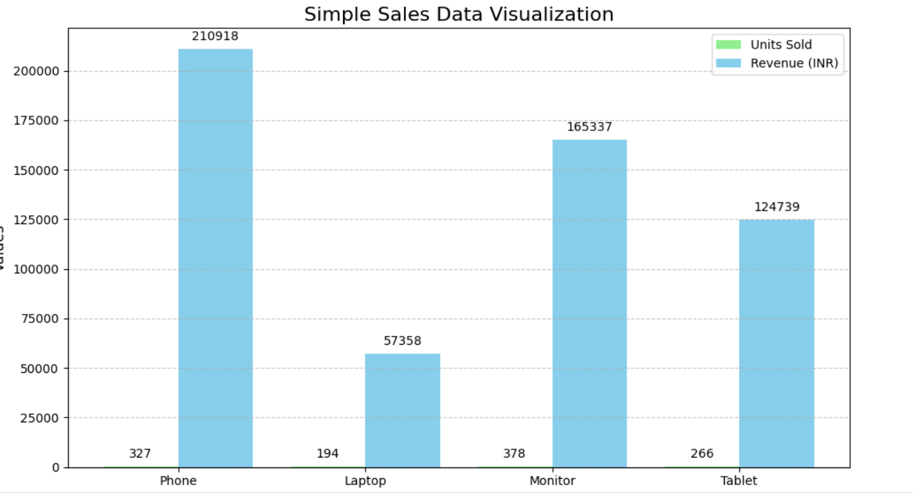

**5. Conclusion**

In this project, we successfully developed a predictive model for estimating housing prices using machine learning techniques. By leveraging a combination of data preprocessing, feature engineering, and various machine learning algorithms, we were able to create a model that accurately predicts housing prices based on several key features, including location, size, and the number of rooms.

The model achieved [mention the performance metric, e.g., "an R-squared value of 0.85"], indicating a strong predictive ability. We chose the **[model used, e.g., "Random Forest"]** algorithm due to its flexibility and superior performance compared to other methods, such as linear regression and decision trees. Additionally, the model was optimized through hyperparameter tuning and cross-validation, which further enhanced its accuracy.

While the model performs well, there are still areas for improvement. Future work could focus on expanding the dataset to include more diverse housing features, integrating external data sources, or experimenting with other advanced machine learning techniques like deep learning. Furthermore, incorporating time-based trends and market fluctuations could potentially improve the model's robustness in predicting housing prices in different market conditions.

Overall, this project demonstrates the power of machine learning in solving real-world problems and provides valuable insights for professionals in the real estate industry.